Hope of Israel Ministries (Ecclesia of YEHOVAH):
The 120 Jubilee Year Calendar According to
Scripture
It is evident that YEHOVAH God's return (see Revelation 19:11-16) will take place on the 120th Jubilee, on Yom Kippur, when He will personally sound the “trumpet of the Jubilee.” This of course corresponds to the “trumpet of God” which “the LORD Himself” will blow. He will blow the Jubilee trumpet “immediately after the tribulation” (Jacob's Trouble). This Jubilee trumpet is the “last trumpet” which Paul associated with the coming of YEHOVAH God Himself and the resurrection.

by Tim Warner
In Leviticus 25, we learn of YEHOVAH God’s Jubilee calendar of 50-year cycles which YEHOVAH commanded Israel to observe. The 50th year is called the “year of release” or “year of liberty” because all land reverted back to its original owner and all debts were cancelled. This Jubilee Year followed every seven Sabbatical cycles (weeks of years), 7x7 years totaling 49 years. The Jubilee was the intercalated 50th year. It did not coincide with the 7th Sabbatical year, but followed it, rounding out the 7 weeks of years to an even 50 years. [1]
Sabbatical & Jubilee Cycle Calendar
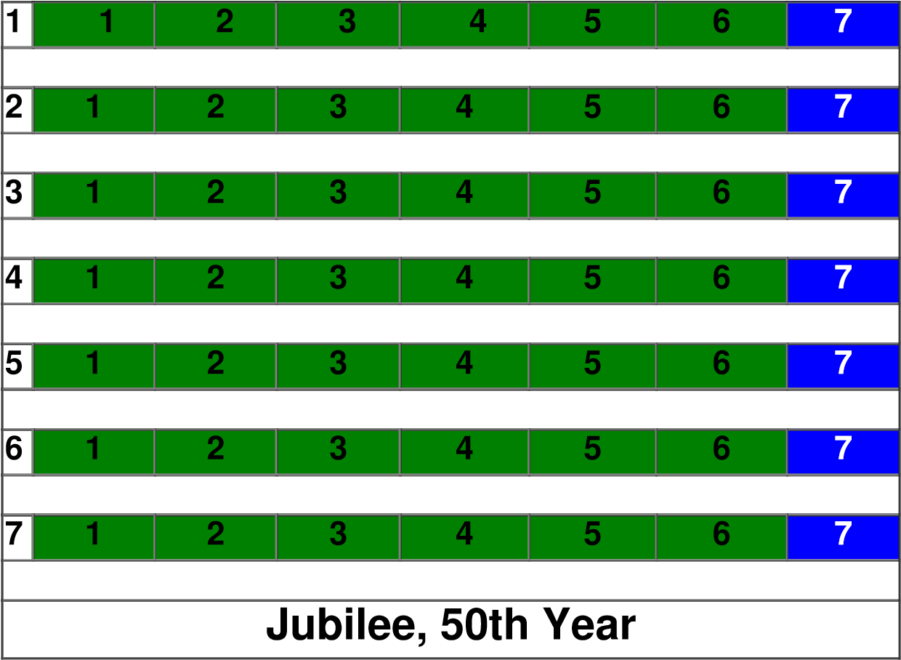
Many modern scholars claim that the Jubilee cycle is 49 years, not 50. They base this idea on alleged practical problems with having two years in a row of not farming the land (the 49th and 50th), and some of Josephus’ reckoning of Sabbatical years without an intercalated 50th Jubilee year. These scholars propose that the Jubilee year is the 49th year, the regular Sabbatical year.
Yet, Jewish sources claim that prior to the Babylonian exile, the Israelites observed the 50 year cycle [2] (albeit not consistently), and that only after the exile did they cease to observe the Jubilee year altogether. That YEHOVAH God Himself reckoned the Jubilee year to be the 50th year, not the 49th year, is stated plainly in Leviticus 25. And we have a clear example of a Jubilee year being observed following a Sabbatical year.
During the 15th year of the reign of Hezekiah, the kingdom of Judah was being threatened by the king of Assyria. King Hezekiah was so troubled by this, he prayed to the LORD for deliverance. YEHOVAH sent Isaiah to him with a message -a sign -- to prove to him that the Assyrians would not defeat Judah.
Isaiah 37:30: “This shall be a sign to you: You shall eat this year such as grows of itself, And the second year what springs from the same; Also in the third year sow and reap, Plant vineyards and eat the fruit of them” (NKJV).
This is a direct reference to the Sabbatical and Jubilee promise in Leviticus 25. The Israelites had not kept the Sabbatical and Jubilee years for some time. Yet, YEHOVAH’s original promise was that He would cause abundant crops to grow to feed them for the Sabbatical and Jubilee years when they did not plant or reap. The sign YEHOVAH gave Hezekiah was the spontaneous abundance of crops, enough for two more years. And YEHOVAH clearly said that they would eat of these crops without farming the land for two consecutive years, and begin to plant again the third year. Therefore, it is abundantly clear that the Jubilee year follows the seventh Sabbatical year, and is not identical with it. This passage also establishes the 15th and 16th years of Hezekiah as a Sabbath and a Jubilee year.
Therefore, we conclude that according to YEHOVAH’s reckoning (since this was His promise and His sign), the Jubilee cycle is 50 full years, not 49. That Josephus records the Judahites observing consecutive sabbatical weeks without intercalating a 50th year after the close of the Old Testament Scriptures, in no way means that it is correct, since the Judahites by this time had abandoned the Jubilee celebration altogether.
Early Christian writers also acknowledged that the Jubilee cycle was 50 years, not 49 years. Hippolytus expressed this clearly in his commentary on the Psalms.
“Let us inquire, further, why there are one hundred and fifty psalms. That the number fifty is sacred, is manifest from the days of the celebrated festival of Pentecost, which indicates release from labors, and (the possession of) joy. For which reason neither fasting nor bending the knee is decreed for those days. For this is a symbol of the great assembly that is reserved for future times. Of which times there was a shadow in the land of Israel in the year called among the Hebrews “Jobel” (Jubilee) which is the fiftieth year in number, and brings with it liberty for the slave, and release from debt, and the like. …
"Thus, then, it was also meet that the hymns to God on account of the destruction of enemies, and in thanksgiving for the goodness of God, should contain not simply one set of fifty, but three such, for the name of Father, and Son, and Holy Spirit. The number fifty, moreover, contains seven sevens, or a Sabbath of Sabbaths; and also over and above these full Sabbaths, a new beginning, in the eight, of a really new rest that remains above the Sabbaths.” [3]
There is evidence in Scripture that this calendar was in use before Moses and the Law. We learn of Jacob serving Laban for 7 years for each of his wives, a total of 14 years. He then served 6 more years, and departed on the 7th year (a total of 20 years of service), [4] departing at the beginning of the 21st year. In the Law, slaves were to serve for 6 years, and be given their freedom in the 7th year. [5]
Jacob agreed to serve Laban one “week” of years for Leah, and another week of years for Rachael. He then agreed to serve a third week of years for his flocks and goods. Yet, the fact that he left at the end of the 6th year instead of the end of the 7th year strongly suggests that their agreement was in accord with what Moses commanded later concerning the Sabbatical and Jubilee calendar. Therefore, we may infer that Moses merely reemphasized something that was already known, no doubt having been handed down through Noah, and perhaps practiced from the very first year of creation.
Ancient extra-biblical sources also indicate this calendar being in use before Moses. After the Babylonian exile, perhaps shortly after the time of Ezra and Nehemiah, a Hebrew apocalyptic scroll was produced bearing the name “Jubilees,” sometimes called “The Little Genesis.” It purports to give a fuller account of some of the history in Genesis and Exodus. The Book of Jubilees claims to be angelic revelation to Moses during his 40 days on Mount Sinai. It reckons time from creation to the Messianic Kingdom in Jubilee and Sabbatical weeks.
"And He said to the Angel of the Presence: ‘Write for Moses from the beginning of creation till My sanctuary has been built among them for all eternity. And the LORD will appear to the eyes of all, and all will know that I am the God of Israel and the Father of all the children of Jacob, and King on Mount Zion for all eternity. And Zion and Jerusalem will be holy.’

"And the Angel of the Presence who went before the camp of Israel took the tables of the divisions of the years - from the time of the creation -- of the law and of the testimony of the weeks, of the Jubilees, according to the individual years, according to all the number of the Jubilees [according to the individual years], from the day of the creation until the heavens and the earth shall be renewed and all their creation according to the powers of the heaven, and according to all the creation of the earth, until the sanctuary of the LORD shall be made in Jerusalem on Mount Zion, and all the luminaries be renewed for healing and for peace and for blessing for all the elect of Israel, and that thus it may be from that day and unto all the days of the earth.” [6]
The Jubilee calendar was intended to count down to the establishment of the Messianic Kingdom on the earth, when the heavens and earth will be made new. According to the author, all of history recorded in the Hebrew Bible is to be reckoned on this divine calendar, from creation to the Messianic Kingdom. The Book of Jubilees gives the creation account and includes the genealogies of Genesis, except that the dates are given in Jubilee cycles and Sabbatical years (according to the Jubilee calendar in Leviticus 25).
“And in the fifth week of the fifth Jubilee Seth took Azura his sister to be his wife, and in the fourth year of the sixth week she bore him Enos. He began to call on the name of the LORD on the earth. And in the seventh Jubilee in the third week Enos took Nôâm his sister to be his wife, and she bare him a son in the third year of the fifth week, and he called his name Kenan.
"And at the close of the eighth Jubilee Kenan took Mûalêlêth his sister to be his wife, and she bare him a son in the ninth Jubilee, in the first week in the third year of this week, and he called his name Mahalalel. And in the second week of the tenth jubilee Mahalalel took unto him to wife Dînâh, the daughter of Barâkî’êl the daughter of his father's brother, and she bare him a son in the third week in the sixth year, and he called his name Jared.”

[7]
While none of the early Christian writers who taught the Millennial week (6,000 years + Millennial Sabbath) mentioned this Jubilee calendar specifically, some of them quoted from the book of Jubilees, including Justin. Obviously they were familiar with the main thrust of this book -- the idea of a divine Jubilee calendar spanning from creation to the Messianic Kingdom. They already saw this time period as a week of millennia, with 6,000 years from Adam to the Messianic Kingdom

Perhaps the reason they did not mention the Jubilee creation calendar specifically was because the Book of Jubilees follows the Hebrew text for the genealogies in Genesis, while the early Christians used the Septuagint’s much longer genealogies. [8] Thus, the Book of Jubilees would not agree with their Greek Old Testament. Also, Jubilees uses a 49 year Jubilee cycle, which would not divide equally into 6,000 years. However, when these two things are corrected (using the Hebrew text dates, and a 50 year cycle), there is perfect harmony between the Millennial Week and the main premise of the Book of Jubilees, with the 6,000 years being divided into 120 Jubilee cycles.
Moses recorded a very curious statement by YEHOVAH God in Genesis 6:3. “And the LORD said, ‘My spirit shall not strive with [Adamic] man forever, for he is indeed flesh; yet his days shall be one hundred and twenty years’.” The period of 120 years in this passage has usually been interpreted one of two ways:
- Many suppose that YEHOVAH God was limiting the life spans of humans to 120 years each. Yet, after the flood many people lived to well beyond this age. Human life spans did decline over time, but not until many years after the flood. And they did not settle to around 120, but to around 70-80. [9]
- Others think YEHOVAH God was speaking of the duration of time until He would destroy the earth with a flood. Yet, thecontext indicates that YEHOVAH made this statement after Noah reached 500 years old. [10] It was therefore less than 100 years until the flood which came in Noah’s 600th year. [11] Some commentators have suggested that YEHOVAH God originally designated 120 years, but shortened it because of Adamic man’s wickedness. [12] Others claim that the narrative is out of sequence, YEHOVAH making this statement before the events recorded in the previous chapter. [13] Yet, none of these explanations seem adequate or natural. Instead, a third solution solves the difficulty and presents us with a golden nugget.
In the Hebrew text, “man” is singular and has the definite article. The Hebrew literally reads, “My spirit shall not remain among the adam forever.” Adam was both the name of the first man and also the whole Adamic race, the Hebrew word “adam” meaning “man.” This passage almost certainly indicates that the spirit’s struggle with the whole Adamic race is limited to 120 years. This cannot refer to the flood, because the Adamic race survived the flood. YEHOVAH’s spirit still struggles with the Adamic race after the flood. And the flood occurred in less than 100 years. Obviously, then, the period of 120 years cannot refer to normal years.
When we calculate the genealogies in Genesis 5 using this 50 year Jubilee calendar, we discover that YEHOVAH God made the statement, “My spirit shall not strive with man forever,…yet his days shall be one hundred and twenty years,” on the 31st Jubilee year, the year 1550 from creation! YEHOVAH made this statement in Noah’s 500th year. As we will prove in the next article, Noah was born in 1051.5 AM, making his 500th year 1550.5 AM. [14]
This is precisely the middle of the 31st Jubilee year from creation. Thus, when YEHOVAH God said “yet his days shall be 120 years” it is no stretch to suppose that He meant these (Jubilee) years which only occur every 50 regular years. If the statement limiting YEHOVAH’s struggle with Adamic man to 120 years refers to Jubilee years, it becomes obvious that the cycle of Jubilee years must be counted from the year of creation, when YEHOVAH’s struggle with Adam and his line began.
Ussher and others have long ago identified the fall of Adamic man as occurring on the 3rd day following creation week. Adamic Man was created on the 6th day of creation and fell into sin on the 10th day of creation. This was inferred by Ussher from the festival of Yom Kippur (Day of Atonement), which marks the anniversary of the fall of Adamic man on the 10th day of the first month [15] (on the Jewish civil calendar). [16] Ussher’s claim is strongly supported by the symbolism of this festival.
The two goats on the Day of Atonement symbolized the fall of Adamic man and his expulsion from Eden. [17] The first goat was sacrificed for Adamic man’s sins and its blood sprinkled on the Ark of the Covenant by the high priest once a year on the Day of Atonement, symbolizing Adamic man’s need for the atonement of Yeshua the Messiah. [18] The second goat was the scape goat. The high priest laid his hands on the head of this goat, symbolically transferring the sins of the people to the scape goat. [19] It was then abandoned in the wilderness, illustrating Adam’s expulsion from Eden carrying his guilt. Since the Day of Atonement occurs on the 10th day following the first day of the first month, which is Rosh Hashanah marking the first day of creation, we date the fall of Adam to Yom Kippur, Tishri 10, year 1.

It is no coincidence that the Jubilee trumpet is only sounded on Yom Kippur, marking the beginning of the year of Jubilee (50th year). Yom Kippur is the 10th day of the first month (on the civil calendar). [20] Therefore the Jubilee year is offset from the regular civil years by 10 days, beginning 10 days later than regular years. If we count exactly 120 Jubilee years from the fall of man on Tishri 10th of year 1, the return of YEHOVAH God must also be on Yom Kippur six thousand years later in order to fulfill the 120 Jubilee years to the very day. [21] The return of YEHOVAH God will occur on a Jubilee year, when “liberty” is proclaimed, as Isaiah proves:
Isaiah 61:1-7: "The spirit of the LORD is upon me, because he has anointed me; he has sent me to preach glad tidings to the poor, to heal the broken in heart, to proclaim liberty to the captives, and recovery of sight to the blind; to declare the acceptable year of the LORD, and the day of recompence; to comfort all that mourn; that there should be given to them that mourn in Sion glory instead of ashes, the oil of joy to the mourners, the garment of glory for the spirit of heaviness: and they shall be called generations of righteousness, the planting of the LORD for glory.
"And they shall build the old waste places, they shall raise up those that were before made desolate, and shall renew the desert cities, even those that had been desolate for many generations. And strangers shall come and feed thy flocks, and aliens shall be thy ploughmen and vine-dressers. But ye shall be called priests of the LORD, the ministers of God: ye shall eat the strength of nations, and shall be admired because of their wealth. Thus shall they inherit the land a second time, and everlasting joy shall be upon their head” (LXX).
Compare this passage with the following instructions for the Jubilee year:
Leviticus 25:8-11: “And you shall count seven sabbaths of years for yourself, seven times seven years; and the time of the seven sabbaths of years shall be to you forty-nine years. Then you shall cause the trumpet of the Jubilee to sound on the tenth day of the seventh month; on the Day of Atonement you shall make the trumpet to sound throughout all your land. And you shall consecrate the fiftieth year, and proclaim liberty throughout all the land to all its inhabitants. It shall be a Jubilee for you; and each of you shall return to his possession, and each of you shall return to his family" (NKJV).
The Messiah read from the passage in Isaiah in the synagogue of Nazareth, referring to the statements about preaching glad tidings to the poor, and proclaiming the year of liberty (Jubilee). Did the Messiah preach about the year of Jubilee? Yes, if this refers to YEHOVAH God's return to establish His Kingdom on the earth. The Messiah proclaimed “the Gospel of the Kingdom,” [22] and had a great deal to say about YEHOVAH God's return and the Kingdom.
It is evident therefore that YEHOVAH God's return (see Revelation 19:11-16) will take place on the 120th Jubilee, on Yom Kippur, when He will personally sound the “trumpet of the Jubilee.” [23] This of course corresponds to the “trumpet of God” [24] which “the LORD Himself” will blow. [25] He will blow the Jubilee trumpet “immediately after the tribulation” (Jacob's Trouble). [26] This Jubilee trumpet is the “last trumpet” which Paul associated with the coming of YEHOVAH God Himself and the resurrection. [27] It is the “last trumpet” because it is the 120th Jubilee trumpet!
Our proposed Jubilee calendar, of 120 Jubilee years from creation to the second appearance, can be tested and verified. If we can establish from biblical data an accurate chronology from the creation until the Israelites began using the Jubilee calendar under Joshua, and if the Jubilee years on our creation calendar synchronize with Joshua’s Jubilee calendar, this is sufficient proof for our Jubilee calendar theory. There is only a 1 in 50 chance that our creation calendar would synchronize perfectly with Joshua’s actual Jubilee calendar by chance.
Not only does our creation Jubilee calendar synchronize perfectly with Joshua’s Jubilee calendar, but the year of the exodus from Egypt, which was above all else the “year of release,” [28] falls exactly on the 50th Jubilee year from creation, the year 2,500. If every 50th regular year is a “Jubilee,” the 50th Jubilee year (50x50) would be a Jubilee of Jubilees! It cannot be mere coincidence that the “year of release” from Egypt, the “year of liberty” [29] from slavery, falls in precisely the middle of the 2500th year, the Jubilee of Jubilees!
But, there is more. The decree of Cyrus, setting the Judahites at liberty after the 70 years captivity, falls on the 70th Jubilee! Jeremiah prophesied that the captivity would end after 70 years. [30] And sure enough, it lasted exactly 70 regular years. However, the year of their release from captivity was also the 70th Jubilee year from creation! Coincidence? Hardly!
Here’s more. The birth of Abraham was on the 40th Jubilee. The birth of Isaac was also on the 42nd Jubilee year. YEHOVAH God gave David the Davidic Covenant, the promise of the Messiah from his loins, on the 59th Jubilee year! The 70 weeks prophecy in Daniel 9 begins on the 70th Jubilee year. And the “70th week” of Daniel (the 7 year tribulation) necessarily ends on the day before the 120th Jubilee, at sundown on Tishri 9th, exactly 6,000 years from Adam’s expulsion from Eden! [31] We will demonstrate the above in the articles to follow, which will develop a complete chronology from the Bible, from creation to the return of YEHOVAH God to reside in Jerusalem with His people Israel.
Footnotes:
- King Hezekiah celebrated a Sabbatical year followed by a Jubilee year, (Isaiah 37:30).
- The Sedar Olam Rabbah, the ancient 2nd century Jewish chronology, the oldest word on the subject, states plainly that the Jubilee cycles were a full 50 years. (Sedar Olam Rabbah, ch. 11, translated by Ken Johnson, PhD., p. 61) [3] Hippolytus, Commentary on Psalms, I, 3-4
- Genesis 31:41
- Exodus 21:2
- Book of Jubilees, Charles’ Translation, pp. 32-33
- Ibid. p. 52
- The Septuagint gives greater ages for the patriarchs when their sons were born than the Hebrew text. The Septuagint systematically adds 100 years per generation. For example, the Hebrew says that Adam was 130 years old when Seth was born, but the LXX says 230 years. The Hebrew says that Seth was 105 when Enos was born. The LXX says he was 205. This one hundred years per generation error compounds, making the Genesis genealogies in the LXX too long by over 1500 years. Because of this, the early Christians thought that they were much closer to the end of the 6000 years than they actually were.
- Psalm 90:10
- Genesis 5:32
- Genesis 7:6
- John Gill’s Commentary on Genesis 6:3
- Albert Barnes Commentary on Genesis 6:3
- Inclusive reckoning, explained in the next chapter
- Leviticus 23:26
- The civil calendar is the original calendar used by Moses to date the genealogies. It begins on the new moon in September. This was the only calendar in use until YEHOVAH God commanded Moses to add a second calendar for tracking the festivals. This festival calendar began on the first day of the month in which YEHOVAH God led the Israelites out of Egypt, in the spring. From the time of the exodus onward, the Israelites (then the Jews) have kept both calendars 6 months apart. The civil (original) calendar (fall to fall) was used to calculate the sabbatical weeks of years for planting and harvesting, and for the year of Jubilee. The festival calendar was used for everything else. Consequently, the Day of Atonement is on the 10th day of the 1st month on the civil calendar, and on the 10th day of the 7th month on the festival calendar.
- Leviticus 16:7-10
- Hebrews 10:1-4
- Leviticus 16:21
- Leviticus 25:8-12. The civil calendar is offset from the festival calendar by 6 months, making Yom Kippur the 10th day of the 7th month when reckoned on the festival calendar.
- Inclusive reckoning
- Matthew 4:23
- Levticus 25:9
- 1 Thessalonians 4:16
- Zechariah 9:14
- Matthew 24:29-31
- 1 Corinthians 15:52
- Leviticus 25:10: “And ye shall sanctify the year, the fiftieth year, and ye shall proclaim a release upon the land to all that inhabit it; it shall be given a year of release, a jubilee for you; and each one shall depart to his possession, and ye shall go each to his family” (LXX)
- Ezekiel 46:17 calls the Jubilee “the year of liberty.”
- 2 Chronicles 36:21; Jeremiah 29:10; Daniel 9:1-2
- Inclusive reckoning

-- Edited by John D. Keyser

Hope of Israel Ministries -- Preaching YEHOVAH's Truth to the Modern Descendants of Israel Without Fear or Favor!
 | Hope of Israel Ministries  P.O. Box 853  Azusa, CA 91702, U.S.A.  www.hope-of-israel.org | Scan with your Smartphone for more information

