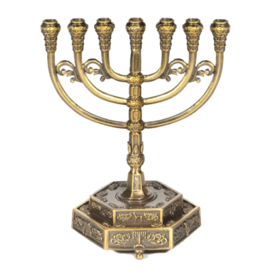 **Hope of Israel Ministries P.O. Box 853 Azusa, CA 91702, U.S.A.**

December 21, 2023.

**YEHOVAH’s New Moons**

While the ancient Israelites were fully capable of mathematically determining the New Moons, YEHOVAH God required that the first faint sliver of the New Moon be visibly observed over Jerusalem as verification.

If the New Moon could not be visibly observed when expected, the next day became the New Moon day for determining the weekly and annual Sabbaths.

Since the New Moons could only be observed after sunset, and YEHOVAH’s days run from sunset to sunset, then if the New Moon is observed, for example, after sunset on the 15th on our calendar, the next day (16th) would be the New Moon Day. (Sunset on the 15th to sunset on the 16th).

To verify if the New Moon is seen when expected, you can go to [www.paleotimes.org](http://www.paleotimes.org) for confirmation. They have people in Israel and Jerusalem watching every month for the New moon.

YEHOVAH’s blessings,

John Keyser for Hope of Israel Ministries.

[**www.hope-of-israel.org**](http://www.hope-of-israel.org) **ecclesia.of.yehovah@protonmail.com**